Kernel Window: Peeping through /proc

Useful kernel windows

The /proc file system (procfs) is a special file system in the linux kernel. It’s a virtual file system: it is not associated with a block device but exists only in memory. The files in the procfs are there to allow userland programs access to certain information from the kernel (like process information in /proc/[0-9]+/ ), but also for debug purposes (like /proc/ksyms ).
Note that the files in /proc/sys are sysctl files: they don’t belong to procfs and are governed by a completely different API described in the Kernel API book.
/proc virtual file-system (using cat), to help us out in decoding the various nitty-gritties of Linux device drivers. Here’s a non-exhaustive summary listing:

. /proc/modules – Listing of all the dynamically loaded modules
- /proc/devices – Listing of all the registered character and block major numbers
- /proc/iomem – Listing of on-system physical RAM & bus device addresses
- /proc/ioports – Listing of on-system I/O port addresses (specially for x86 systems)
- /proc/interrupts – Listing of all the registered interrupt request numbers
- /proc/softirqs – Listing of all the registered soft irqs
- /proc/kallsyms – Listing of all the running kernel symbols, including from loaded modules
- /proc/partitions – Listing of currently connected block devices & their partitions
- /proc/filesystems – Listing of currently active file-system drivers
- /proc/swaps – Listing of currently active swaps
- /proc/cpuinfo – Information about the CPU(s) on the system
- /proc/meminfo – Information about the memory on the system, viz. RAM, swap, …
Custom kernel windows
example1
And then do the following steps:
. Built the driver (proc_window.ko file) using the usual driver’s Makefile.
- Loaded the driver using insmod.
- Showed various experiments using the newly created proc windows.
- And finally, unloaded the driver using rmmod.
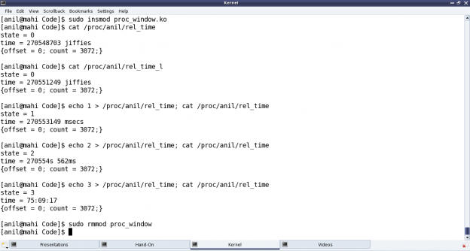

Demystifying the details

Starting from the constructor proc_win_init(), three proc entries are created:
* Directory khan under /proc (i.e. NULL parent) with default permissions 0755, using proc_mkdir()
* Regular file rel_time under the above directory khan with permissions 0666, using create_proc_entry() or proc_create() (since kernel v3.10)
* Soft link rel_time_l to the above file rel_time under the same directory khan, using proc_symlink()

The corresponding removal of these three is achieved using remove_proc_entry() in the destructor proc_win_exit(), in chronological reverse order.
For every entry created under /proc, a corresponding struct proc_dir_entry is created. After which many of its fields could be further updated as needed:

* mode – Permissions of the file
* uid – User ID of the file
* gid – Group ID of the file

Since kernel v3.10, specific API proc_set_user() has been provided to update the uid & gid, instead of directly modifying the fields.
Additionally, for a regular file, the following two function pointers for read and write over the file could be provided, respectively:

i) int (*read_proc)(char *page, char **start, off_t off, int count, int *eof, void *data)
ii) int (*write_proc)(struct file *file, const char __user *buffer, unsigned long count, void *data)

Again, since kernel v3.10, the read & write fields of struct file_operations are to be used respectively, instead of the above two.
write_proc() is very similar to the character device file operation write. And the above code implementation, lets the user to write a digit from 0 to 9, and accordingly sets the internal state.
read_proc() in the above code implementation provides the current state and the time since the system has been booted up in different units based on the current state. These are, jiffies in state 0; milliseconds in state 1; seconds & milliseconds in state 2; hours : minutes : seconds in state 3; and <not implemented> in other states. And to check the computation accuracy, Figure highlights the system up time in the output of top. read_proc()‘s page parameter is a page-sized buffer, typically to be filled up with count bytes from offset off. But more often than not (because of small content), just page is filled up, ignoring all other parameters. Since kernel v3.10, the read logic has to be implemented through something called a sequence file, which is implemented by specifying the pre-defined seq_read() function for the file operation read, and then by providing the above logic in the sequence file’s read function through the file operation open using single_open().

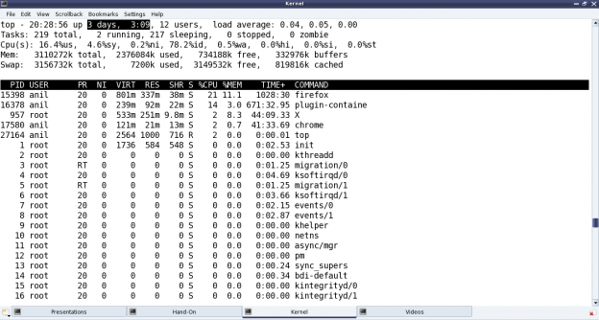

All the /proc related structure definitions and function declarations are available through <linux/proc_fs.h>. The sequence file related stuff (since kernel v3.10) are available through <linux/seq_file.h>. And the jiffies related function declarations and macro definitions are in <linux/jiffies.h>. On a special note, the actual jiffies are being calculated by subtracting INITIAL_JIFFIES, as on boot-up, jiffies is initialized to INITIAL_JIFFIES instead of zero.

Notes

One of the powerful usage of creating our own proc window is for customized debugging by querying. A simple but cool modification of the above driver, could be instead of getting the jiffies, it could read / write hardware registers.

